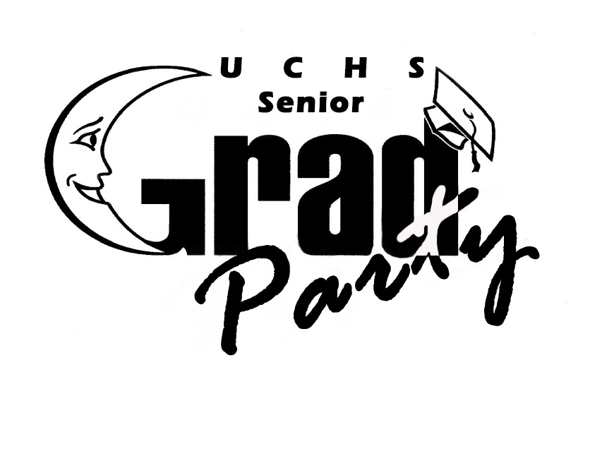 STUDENT & PARENT AGREEMENT
UCHS SENIOR GRAD PARTY
TICKET ORDER FORM
JUNE 13, 2018 9pm to 4am

ALL PAGES MUST BE COMPLETELY FILLED OUT & SIGNED
Please Print:
Student Name__________________________________ E-mail____________________________

Parent Name___________________________________ E-mail____________________________

Address ______________________________________________ Student Birthdate____________

Telephone # ( ___ )_________________________Cell # ( __ )__________________________

In order to meet the deadlines noted below, PAYMENT and completed form must either be received in Senior Grad Party mailbox by close of school business day OR if mailed, must be postmarked BEFORE the effective price increase date.
$90 Nov. 18 - March 23 ______
BEST Price!!
$75 until November 17 _____
(last school day before Spring break)
Price Increases to

$105 March 24 - June 12 ______
(last school day before Thanksgiving break)
$115 at the door ______
Free & Reduced Lunch Students
$35 until March 24 ______ $50 March 25 - June 12 _______ $75 at the door ______
PLUS $_______ donation to help offset Senior Grad Party Costs
Please make checks payable to “UCHS PTSA” or pay by credit card at www.uchsptsa.org
Mail to: UCHS PTSA Senior Grad Party, 6949 Genesee Ave., San Diego, CA 92122
Code of Conduct Agreement

BY SIGNING THIS AGREEMENT, STUDENTS AND PARENTS HEREBY AGREE TO ALL TERMS FOR ACCEPTANCE INTO SENIOR GRAD PARTY.

Student, by signing this agreement on page 2 you understand & will abide by the following rules:
1. I must arrive between 9:00pm and 10:00pm. Picture ID is required for admittance.
2. I will not consume alcohol or other drugs the day of Senior Grad Party.
3. I will not bring alcohol, other drugs, e-cigarettes or tobacco to Senior Grad Party.
4. I understand that I will not be allowed to leave without parent/guardian permission.
5. Once I leave, I will not be allowed back into Senior Grad Party.
6. All containers (purses, backpacks, etc.) WILL BE EXAMINED & KEPT AT THE CHECK-IN AREA for safekeeping upon entering Senior Grad Party.
7. Senior Grad Party is not responsible for lost or stolen items.
8. I understand that inappropriate dress and dancing will not be allowed. The decision on propriety of dress and dancing is up to the Senior Grad Party adult chaperones.
9. I will not bring any medications (including No-Doz, etc.) to Senior Grad Party.
10. I waive all claims which I might have against the UCHS PTSA Senior Grad Party Committee and any volunteers involved in setting up and putting on the Senior Grad Party celebration, as a result of any injuries which may occur as a result of the Senior Grad Party celebration or my decision to leave early.
Furthermore, by signing this agreement on page 2, students & parent/guardian agree to the following:
11. UCHS Senior Grad Party is not responsible for me or my actions should I leave after I have checked-in and before the conclusion of Senior Grad Party, with or without parent/guardian knowledge or permission.
12. I/We give Senior Grad Party volunteers permission to use their judgment in obtaining medical services as required for me/my child. I/We give permission to medical personnel to treat me/my child with the understanding that any medical or hospital costs will be our responsibility.
13. I/We assume responsibility, including financial, for any and all damages and injuries to other graduates, the venue and Senior Grad Party volunteers caused by my/my child's actions during Senior Grad Party.
14. I/We understand that photos and video may be taken of me/my child at Senior Grad Party. I/We give Senior Grad Party permission to post pictures of me/my child on Smugmug.com (a password protected photo sharing website), the UCHS PTSA website, and the UCHS PTSA/Senior Grad Party Facebook page.
15. Ticket fees are not refundable, except in severe extenuating circumstances. In such circumstances, approval by Senior Grad Party Chair is required for refund.

PARENT’S APPROVAL AND STUDENT WAIVER
This is a PTSA sponsored event for which we require parental consent for every student.

has my permission to participate in all events relating to UCHS Senior Grad Party, including teaser events during the 2017-2018 school year, and the Senior Grad Party event on June 13, 2018 held on the on the UCHS campus or another acceptable location.
Name of Minor

Furthermore, at this year’s Senior Grad Party, a Mental Illusionist is scheduled to be a part of the entertainment. The stars of the show will consist of volunteers from the audience who will be hypnotized. Unless indicated otherwise below, all students are eligible to be hypnotized by the Mental Illusionist. Permission is also hereby granted for your child to be videotaped during the Mental Illusionist's show. You must check the box below if you do NOT wish for your child to be hypnotized during the show.

 No, I do not wish my child to be in the show, but I give permission for my child to watch the show.

The undersigned parent or guardian assumes all risks in connection with the student’s participation in any and all of the PTSA sponsored activities. I hereby release and discharge the California State PTA, all PTSA officers, employees and agents from all liability, claims or demands for any damage, loss or injury to the student, the student’s property, or parent’s property in connection with participation in these activities, unless caused by the negligence of the PTSA.

I do hereby certify that to the best of my knowledge and belief said minor is in good health. In case of illness or accident, permission is granted for emergency treatment to be administered. It is further understood and agreed that the undersigned will assume full responsibility for any such action, including payment of costs.

I hereby advise that the above named minor has had the following allergies, medicine reactions or unusual physical condition which should be made known to a treating physician or which could limit participation:

_______________________________________________________________________________________________
If none, please write none.

Parent/Guardian:

Parent/Guardian: You will automatically be called at the number below if your graduate does not arrive by 11 pm or wishes to leave Senior Grad Party before 4:00am, unless you initial otherwise below. (Please leave a cell phone number if you will not be at home.)

____ (Initial) I do not need to be called if my graduate does not arrive by 11 pm or wishes to leave before the end of Senior Grad Party.

I give my permission for the above named graduate to participate in the Senior Grad Party at UCHS. We understand and agree to the above conditions. I will be able to be contacted during Senior Grad Party hours. *I understand that my graduate will not be allowed admission into Senior Grad Party and that I will be asked to pick up my student immediately from the venue if he/she is suspected of being under the influence of alcohol and/or drugs. I understand that underage drinking is against the law and will not be tolerated at Senior Grad Party. I waive all claims which my child or I might have against the UCHS PTSA Senior Grad Party Committee and any volunteers involved in setting up and putting on the Senior Grad Party celebration, as a result of any injuries which may occur as a result of the Senior Grad Party celebration or my graduate’s decision to leave early.

____________________________________________ _____________________
Phone # where you can be reached during Senior Grad Party Alternate Emergency Phone

We have read and understand each and every statement on pages 1 and 2 of this form and agree to
abide by all rules of this agreement.

________________________________ __________________________________ _________________
Student’s Name (Please Print) Student’s Signature Date

________________________________ __________________________________ _________________
Parent/Guardian Name (Please Print) Parent/Guardian Signature Date
NO STUDENT WILL BE ALLOWED INTO SENIOR GRAD PARTY WITHOUT COMPLETION OF FORM

